Sample Plan of a Roman House
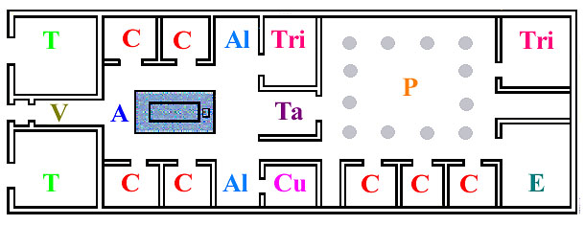
A | atrium | formal entrance hall
Al | ala | "wings" opening from atrium
C | cubiculum | small room; bedroom
Cu | culina | kitchen
E | exedra | garden room
P | peristylium | colonnaded garden
T | taberna | shop
Ta | tablinum | office; study
Tri | triclinium | dining room
V | vestibulum | entrance hall
 | lavortorium | Laundry room
 | stabulum | garage
 | Mea domus | My house
 | Villa romana | Roman villa
